INTRENET OF THINGS (IPCC)
LAB MANUAL

Ex. No: 1 | Develop a program to blink 5 LEDs back and forth.

Aim: Develop a program to blink 5 LEDs back and forth.
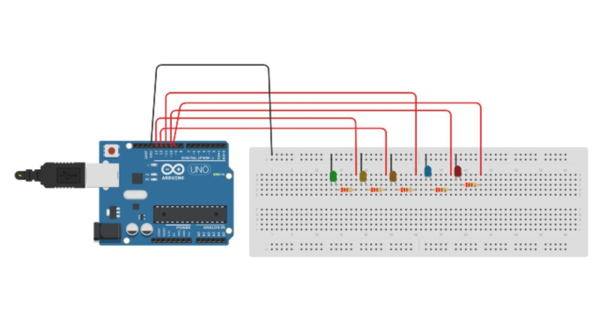
Coding
void setup()
{
pinMode(13, OUTPUT); pinMode(12, OUTPUT); pinMode(11, OUTPUT); pinMode(10, OUTPUT); pinMode(9, OUTPUT);
}
void loop()
{
digitalWrite(13, HIGH);// Wait for 1000 millisecond(s)
delay(1000);
digitalWrite(13, LOW);
delay(1000);
digitalWrite(12, HIGH);
delay(1000);
digitalWrite(12, LOW);
delay(1000); digitalWrite(11, HIGH); delay(1000); digitalWrite(11, LOW); delay(1000); digitalWrite(10, HIGH); delay(1000); digitalWrite(10, LOW); delay(1000); digitalWrite(9, HIGH); delay(1000); digitalWrite(9, LOW); delay(1000);
}

Ex. No: 2 | Develop a program to interface a relay with Arduino board.

Aim: Develop a program to interface a relay with Arduino board.

Circuit Diagram:

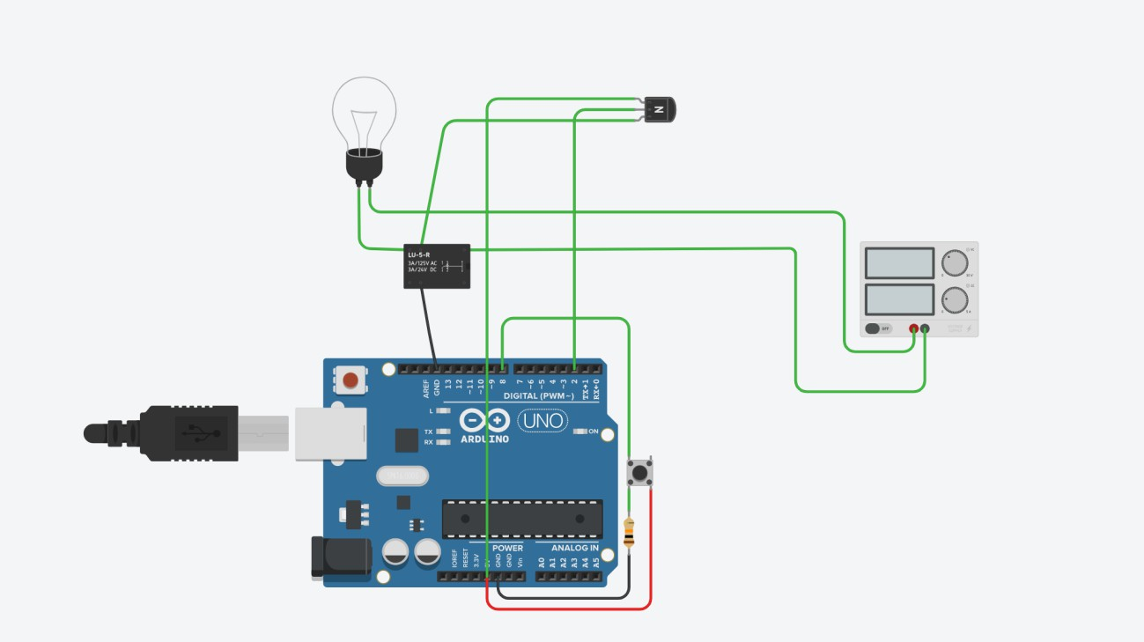
Arduino Code:

void setup()
{
pinMode(3, OUTPUT);
}
void loop()
{
digitalWrite(3, HIGH);
delay(1000); // Wait for 1000 millisecond(s)
digitalWrite(3, LOW);
delay(1000); // Wait for 1000 millisecond(s)
}

Ex.No: 3 &11 | Develop a program to deploy an intrusion detection system using Ultrasonic and sound sensors.
Date:

Aim: Develop a program to deploy an intrusion detection system using Ultrasonic and sound sensors

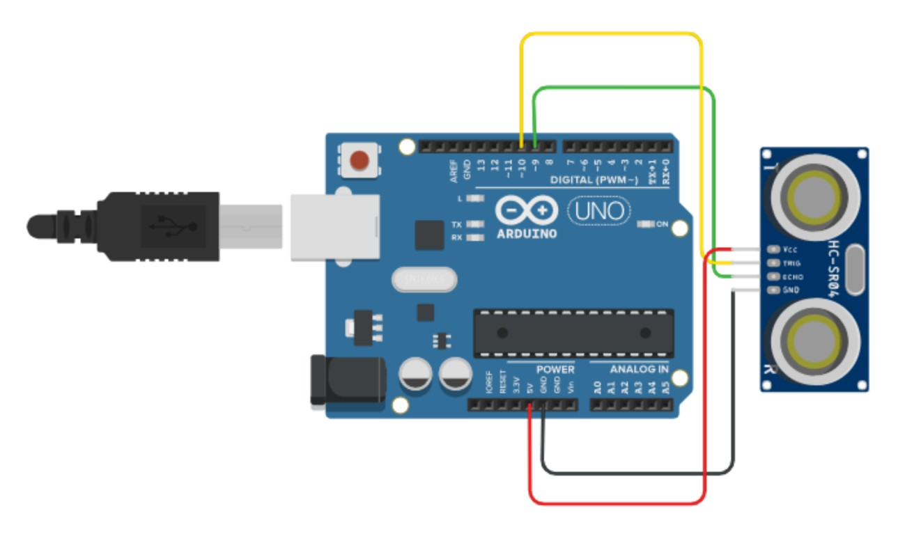

PSUEDOCode :

// C++ code

//

int trigPin = 10; int echoPin = 9; long time;

float distance; void setup()
{

pinMode(trigPin, OUTPUT); // SETTING OUTPUT PIN pinMode(echoPin, INPUT); // SETTING INPUT PIN Serial.begin(9600); // INITIALISING THE COMMUNICATION
}

void loop()

{

digitalWrite(trigPin,LOW); delayMicroseconds(2);
// transmitting sound for 10 microseconds digitalWrite(trigPin, HIGH); delayMicroseconds(10);
digitalWrite(10, LOW);

// calculating distance time=pulseIn(echoPin , HIGH); Serial.print("time: "); Serial.println(time);
distance = time * 0.0343/2;

// Printing out the final output => distance Serial.print("Distance:"); Serial.println(distance);
}

Ex. No: 4 | Develop a program to control a DC motor with Arduino board.

AIM: Develop a program to control a DC motor with Arduino board.

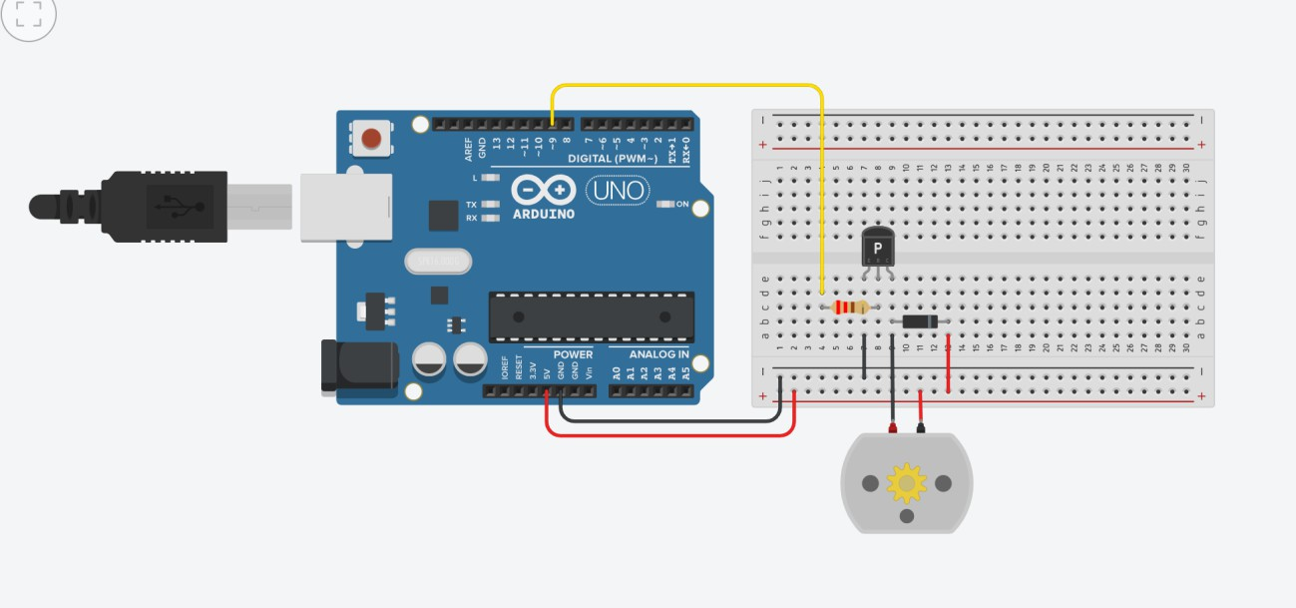

PSUEDO Code:
void setup()
{
pinMode(13, OUTPUT);
pinMode(12, OUTPUT);
}

void loop()
{
digitalWrite(13, HIGH);
delay(1000); // Wait for 1000 millisecond(s)
digitalWrite(12, LOW);
delay(1000); // Wait for 1000 millisecond(s)
digitalWrite(13, LOW);
delay(1000); // Wait for 1000 millisecond(s)
digitalWrite(12, HIGH);
delay(1000); // Wait for 1000 millisecond(s)
}

Ex. No: 5 | Develop a program to deploy smart street light system using LDR sensor.

AIM: Develop a program to deploy smart street light system using LDR sensor

.
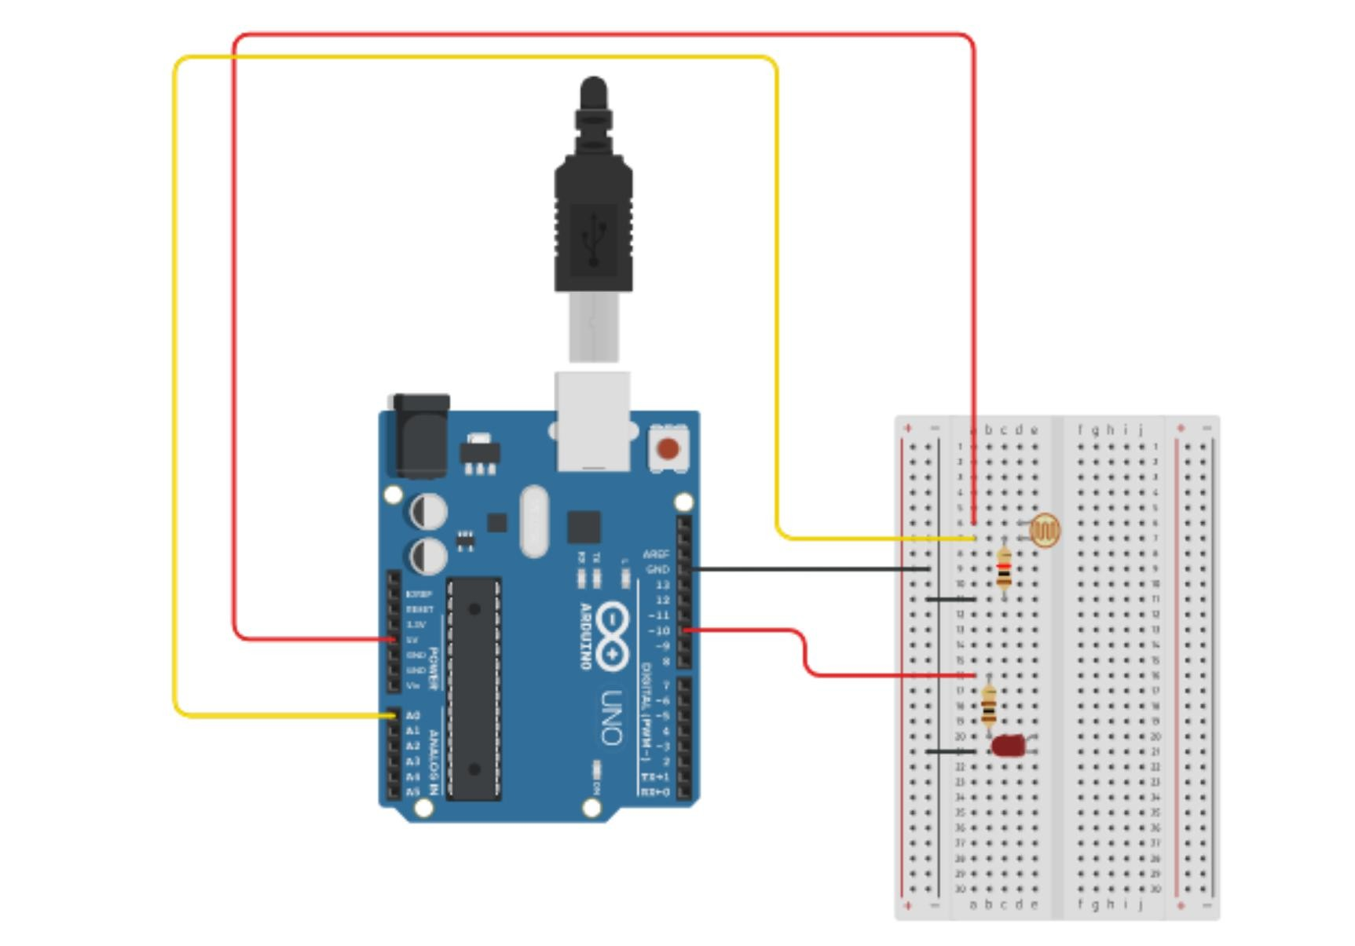

Arduino Code
// C++ code
//
int LDR_VAL = 0;

void setup()
{
pinMode(A0, INPUT);
Serial.begin(9600);
pinMode(8, OUTPUT);
}
void loop()
{
LDR_VAL = analogRead(A0);
Serial.println(LDR_VAL);
if (LDR_VAL > 500) {
digitalWrite(8, HIGH);
}
digitalWrite(8, LOW);
delay(10); // Delay a little bit to improve simulation performance
}

Ex. No: 6 | Develop a program to classify dry and wet waste with the Moisture sensor (DHT22).

Aim: Develop a program to classify dry and wet waste with the Moisture sensor .
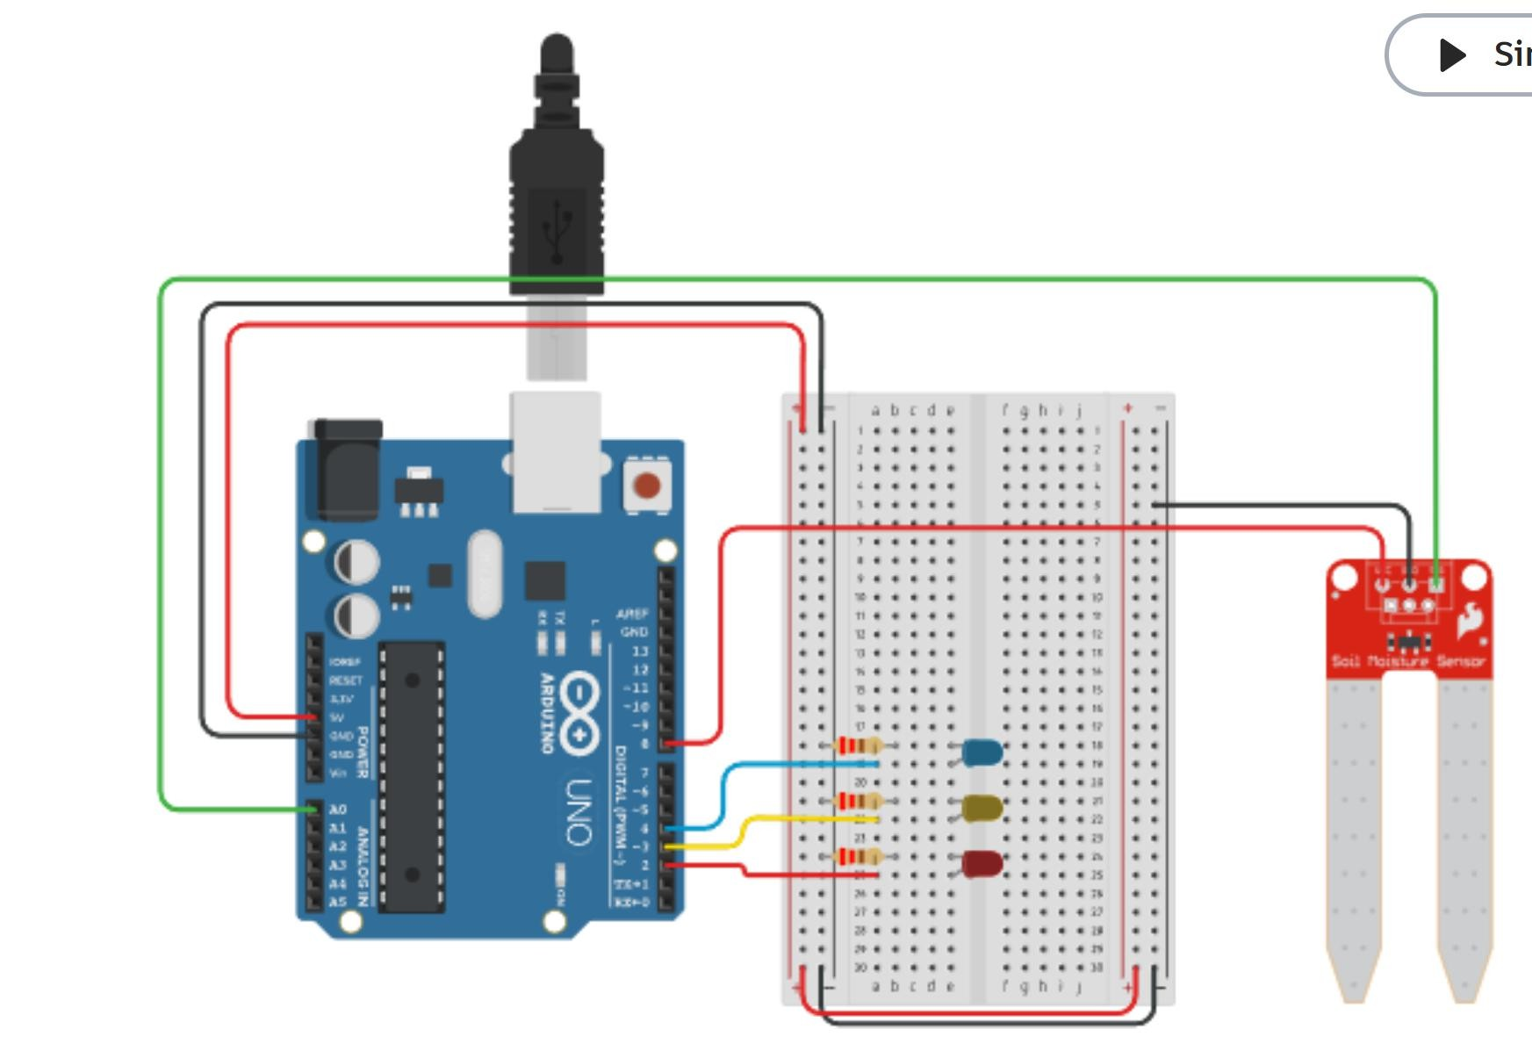

Arduino Code:

// declare variables for pins const int sensorpin = A0; const int sensorpower = 8; const int LED1 = 2;
const int LED2 = 3; const int LED3 = 4;

// variable for sensor reading int sensor;

const int delayTime = 1000;

// "wet" and "dry" thresholds - these require calibration int wet = 800;
int dry = 500;

void setup(){ // code that only runs once
// set pins as outputs pinMode(LED1,OUTPUT); pinMode(LED2,OUTPUT); pinMode(LED3,OUTPUT);
pinMode(sensorpower,OUTPUT);

// initialize serial communication Serial.begin(9600);
}

void loop(){ // code that loops forever
// power on sensor and wait briefly digitalWrite(sensorpower,HIGH); delay(10);
// take reading from sensor sensor = analogRead(sensorpin);
// turn sensor off to help prevent corrosion digitalWrite(sensorpower,LOW);

// print sensor reading Serial.println(sensor);

// If sensor reading is greater than "wet" threshold,
// turn on the blue LED. If it is less than the "dry"
// threshold, turn on the red LED. If it is in between
// the two values, turn on the yellow LED. if(sensor>wet){ digitalWrite(LED1,LOW); digitalWrite(LED2,LOW); digitalWrite(LED3,HIGH);
}
else if(sensor<dry){ digitalWrite(LED1,HIGH);

digitalWrite(LED2,LOW); digitalWrite(LED3,LOW);
}
else{ digitalWrite(LED1,LOW); digitalWrite(LED2,HIGH); digitalWrite(LED3,LOW);
}

// wait before taking next reading delay(delayTime);

}

Ex. No: 7 | Develop a program to read the pH value of a various substances like milk, lime and water.

Aim: Develop a program to read the pH value of a various substances like milk, lime and water.
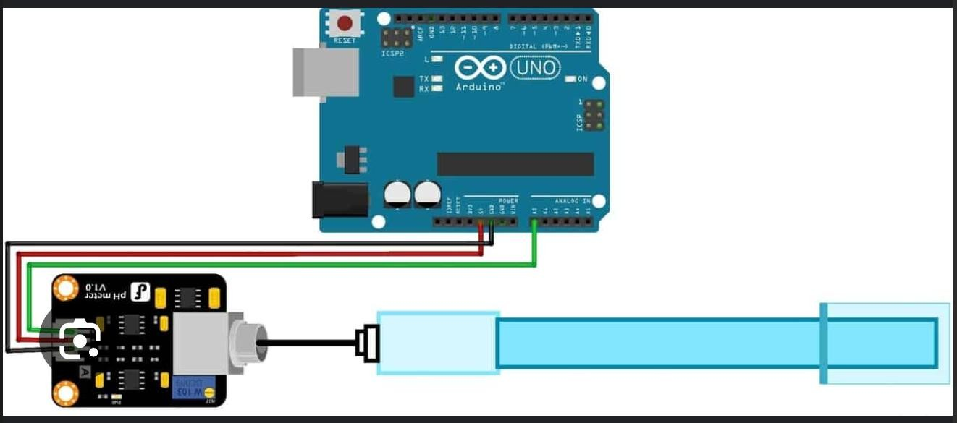

Arduino Code:
/*
# This sample code is used to test the pH meter V1.0. # Editor : YouYou
# Ver : 1.0
# Product: analog pH meter # SKU : SEN0161
*/
#define SensorPin A0 //pH meter Analog output to Arduino Analog Input 0
#define Offset 0.00 //deviation compensate #define LED 13
#define samplingInterval 20
#define printInterval 800
#define ArrayLenth 40 //times of collection

int
pHArray[ArrayLenth];
int pHArrayIndex=0; void setup(void)
{
//Store the average value of the sensor feedback

pinMode(LED,OUTPUT); Serial.begin(9600);
Serial.println("pH meter experiment!"); //Test the serial monitor
}
void loop(void)
{
static unsigned long samplingTime = millis(); static unsigned long printTime = millis();
static float pHValue,voltage;
if(millis()-samplingTime > samplingInterval)
{
pHArray[pHArrayIndex++]=analogRead(SensorPin); if(pHArrayIndex==ArrayLenth)pHArrayIndex=0;
voltage = pHValue =
avergearray(pHArray, ArrayLenth)*5.0/1024; 3.5*voltage+Offset;
samplingTime=millis();
}
if(millis() - printTime > printInterval) //Every 800 milliseconds, print a numerical, convert the state of the LED indicator
{
Serial.print("Voltage:"); Serial.print(voltage,2); Serial.print(" pH value: ");
Serial.println(pHValue,2); digitalWrite(LED,digitalRead(LED)^1);
printTime=millis();
}
}
double avergearray(int* arr, int number){ int i;
int max,min; double avg; long amount=0; if(number<=0){
Serial.println("Error number for the array to avraging!/n");
return 0;
}
if(number<5){ //less than 5, calculated directly statistics
for(i=0;i<number;i++){
amount+=arr[i];
}
avg = amount/number; return avg;
}else{
if(arr[0]<arr[1]){
min = arr[0];max=arr[1];
}
else{
min=arr[1];max=arr[0];
}
for(i=2;i<number;i++){ if(arr[i]<min){
amount+=min; //arr<min
min=arr[i];
}else {
if(arr[i]>max){
amount+=max; //arr>max
max=arr[i];
}else{
amount+=arr[i]; //min<=arr<=max
}
}//if
}//for
avg = (double)amount/(number-2);
}//if return avg;

}

Ex. No: 8 | Develop a program to detect the gas leakage in the surrounding environment.

AIM: Develop a program to detect the gas leakage in the surrounding environment.
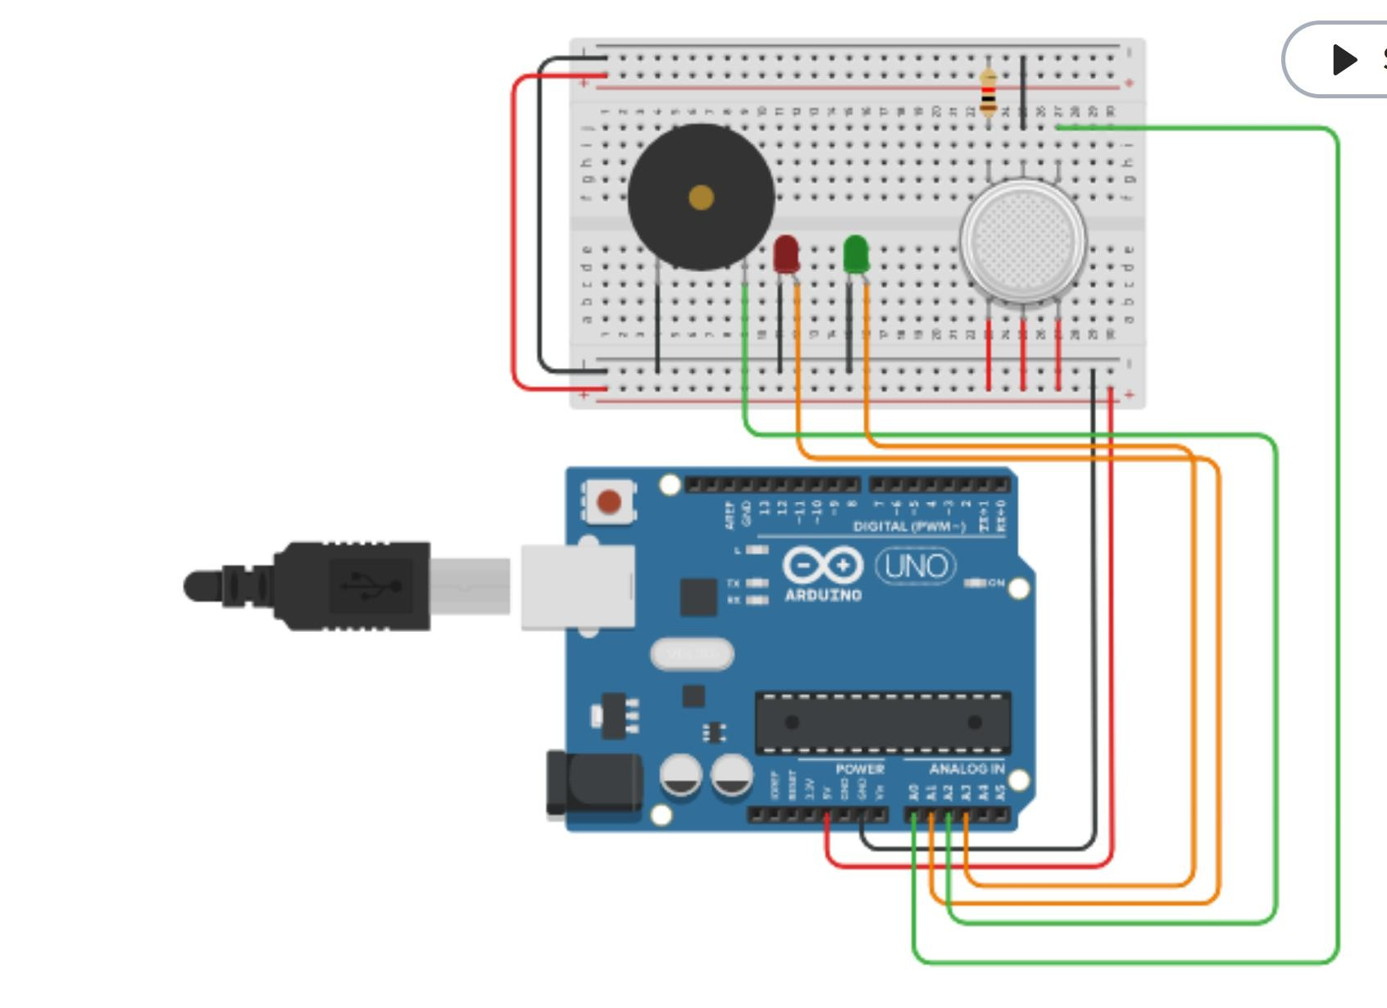

Arduino Code:
int LED = A1; //Red LED
int LED1 = A3; //Green LED
int gas_pin = A0; // For Gas Sensor int buzzer_pin = A2; // For Buzzer

void setup()
{
Serial.begin(9600);
pinMode (buzzer_pin, OUTPUT); pinMode (gas_pin, INPUT);
}

void loop() {
float sensorValue,gas_pin;
sensorValue = analogRead(gas_pin); // read analog input pin 0

if(sensorValue >= 300)
{
digitalWrite(LED,HIGH); digitalWrite(LED1,LOW);

digitalWrite (buzzer_pin, HIGH);
//Serial.println(); Serial.print(sensorValue); Serial.println(" |SMOKE DETECTED|");
}

else
{
digitalWrite(LED,LOW); digitalWrite(LED1,HIGH);

digitalWrite (buzzer_pin, LOW); Serial.println(); Serial.println("Sensor Value: "); Serial.print(sensorValue);
//Serial.print(" |Safe Mode|");
}

delay(1000);

}

Ex. No: 9 | Develop a program to demonstrate weather station readings using Arduino.

Aim: Develop a program to demonstrate weather station readings using Arduino.
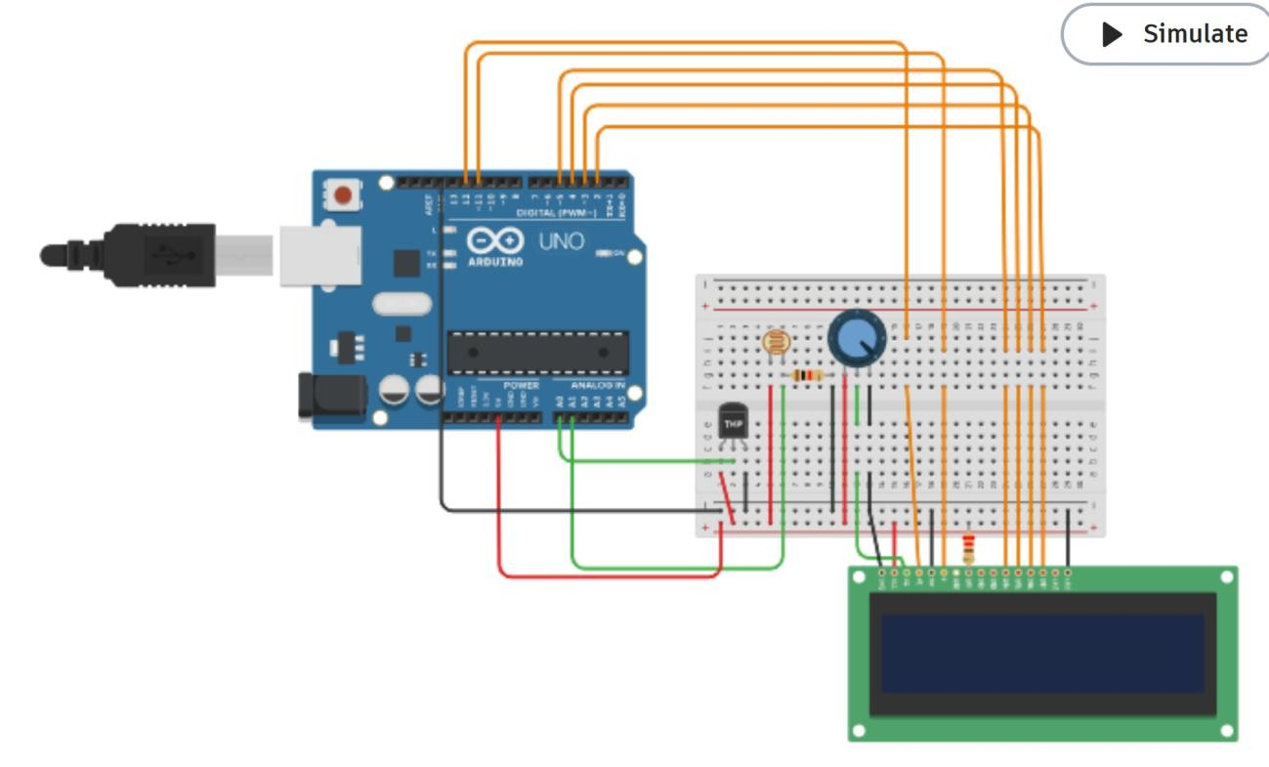

Arduino Code:

#include <LiquidCrystal.h> // including LiquidCrystal Library

LiquidCrystal lcd(12,11,5,4,3,2); // Creating LC object where parameters: (RS,E,DB4,DB5,DB6,DB7)

void setup()

{

lcd.begin(16,2); // 16 Characters per line and 2 lines lcd.setCursor(4,0); // Positioning of the LCD cursor. col=4, row=0

lcd.print("Monitoring"); // Printing text to the LCD lcd.setCursor(7,1); // Positioning of the LCD cursor. col=7, row=1 lcd.print("System"); // Printing text to the LCD
delay(2000); // time delay

}

void loop()

{

lcd.clear(); // Clearing the LCD screen and positioning the cursor in the upper-left corner

float Voltage=analogRead(A0)*0.004882814; // Variable declartion and analog input pin select

float degrees = ( Voltage - 0.5 ) * 100; // Variable declartion and modification

lcd.setCursor(3,0); // Positioning of the LCD cursor. col=3, row=0 lcd.print("Temp:"); // Printing text to the LCD
lcd.setCursor(8,0); // Positioning of the LCD cursor. col=8, row=0 lcd.print(degrees); // Printing text to the LCD
if (degrees<10) // Checking variable value using if function

{

lcd.setCursor(4,1); // Positioning of the LCD cursor. col=4, row=1 lcd.print("-TOO COLD"); // Printing text to the LCD
}

else if(degrees<18 &&degrees>10 ) // Checking variable value using else if function

{

lcd.setCursor(4,1); // Positioning of the LCD cursor. col=4, row=1 lcd.print("-COLD"); // Printing text to the LCD
}

else if(degrees<30 &&degrees>18 ) // Checking variable value using else if function

{

lcd.setCursor(4,1); // Positioning of the LCD cursor. col=4, row=1 lcd.print("-Normal Temp"); // Printing text to the LCD
}

else if(degrees<45 &&degrees>30 ) // Checking variable value using else if function

{

lcd.setCursor(4,1); // Positioning of the LCD cursor. col=4, row=1 lcd.print("-Hot"); // Printing text to the LCD
}

else if(degrees>45 ) // Checking variable value using else if function

{

lcd.setCursor(4,1); // Positioning of the LCD cursor. col=4, row=1 lcd.print("-TOO HOT"); // Printing text to the LCD
}

delay(2000); // time delay

lcd.clear(); // Clearing the LCD screen and positioning the cursor in the upper-left int ldr=analogRead(A1); // Variable declartion and analog input pin select

lcd.setCursor(1,0); // Positioning of the LCD cursor. lcd.print("Intensity:"); // Printing text to the LCD lcd.setCursor(12,0); // Positioning of the LCD cursor. lcd.print(ldr); // Printing text to the LCD
if (ldr<230) // Checking variable value using if function

{

lcd.setCursor(4,1); // Positioning of the LCD cursor. lcd.print("-TOO BRIGHT"); // Printing text to the LCD
}

else if (ldr<460 && ldr>230 ) // Checking variable value using else if function

{

lcd.setCursor(2,1); // Positioning of the LCD cursor. lcd.print("-Medium Light"); // Printing text to the LCD
}

else if (ldr>460) // Checking variable value using else if function

{

lcd.setCursor(4,1); // Positioning of the LCD cursor. lcd.print("-TOO DARK"); // Printing text to the LCD
}

delay(2000); // time delay

lcd.clear(); // Clearing the LCD screen and positioning the cursor in the upper-left corner

}

Ex. No: 12 | Develop a program to simulate interfacing with the keypad module to record the keystrokes.

AIM: Develop a program to simulate interfacing with the keypad module to record the keystrokes.
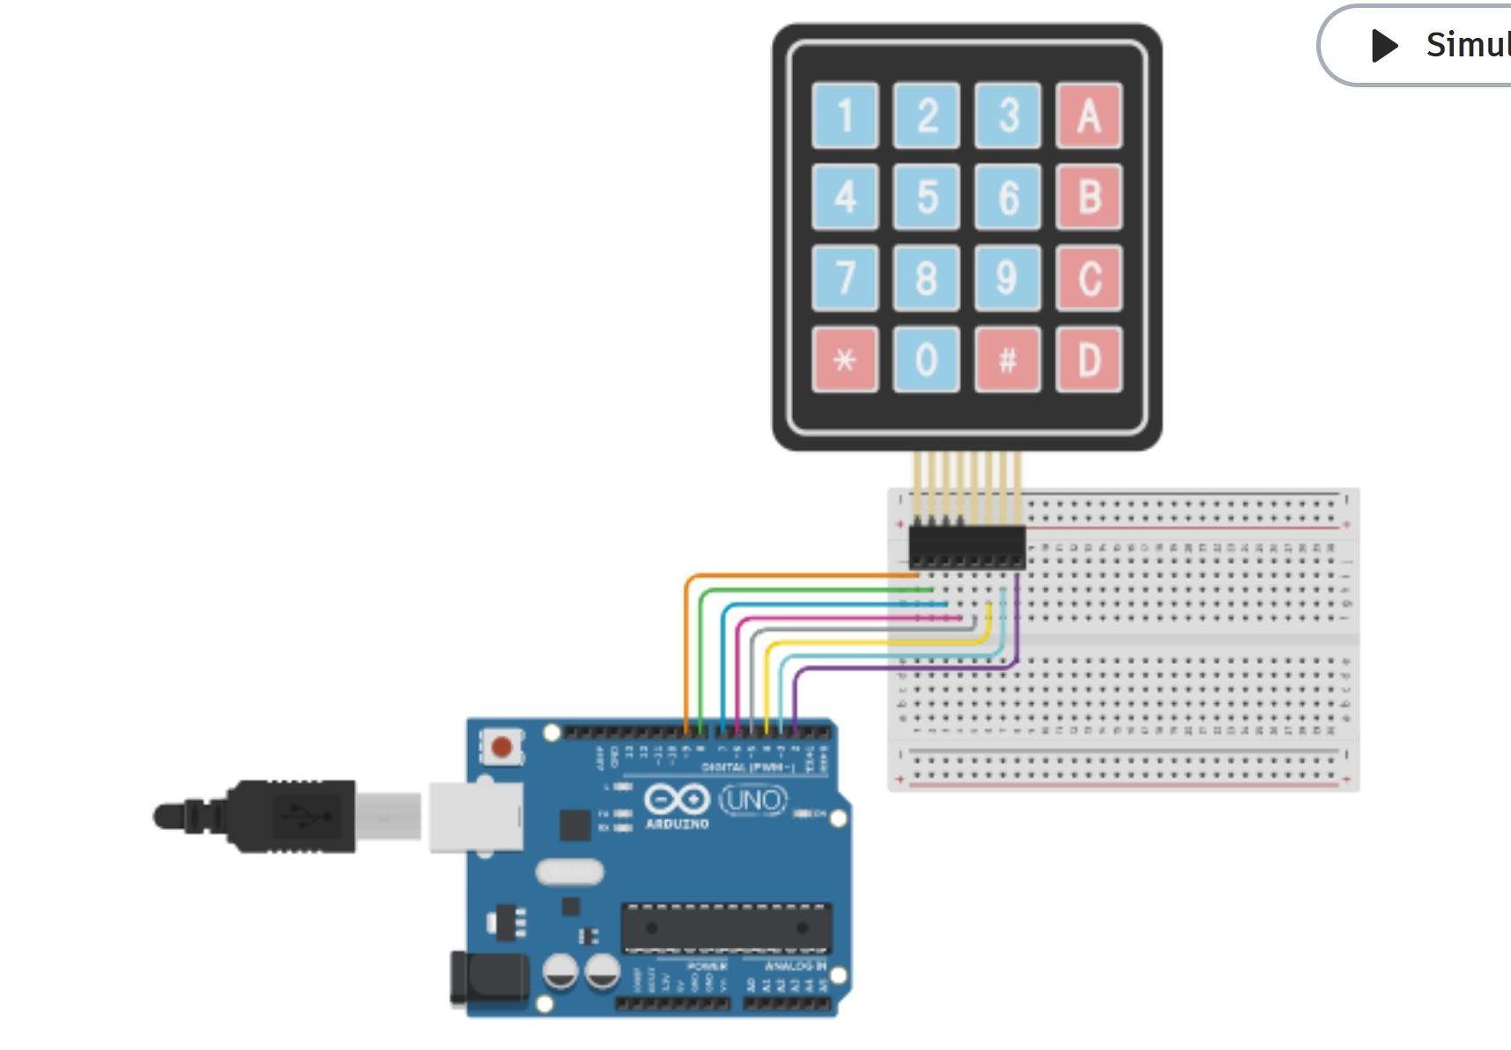

CODE:

#include <Keypad.h>

const byte numRows= 4; //number of rows on the keypad const byte numCols= 4; //number of columns on the keypad

//keymap defines the key pressed according to the row and columns just as appears on the keypad

char keymap[numRows][numCols]=

{

{'1', '2', '3', 'A'},

{'4', '5', '6', 'B'},

{'7', '8', '9', 'C'},

{'*', '0', '#', 'D'}

};

//Code that shows the the keypad connections to the arduino terminals byte rowPins[numRows] = {9,8,7,6}; //Rows 0 to 3
byte colPins[numCols]= {5,4,3,2}; //Columns 0 to 3

//initializes an instance of the Keypad class

Keypad myKeypad= Keypad(makeKeymap(keymap), rowPins, colPins, numRows, numCols);

void setup()

{

Serial.begin(9600);

}

//If key is pressed, this key is stored in 'keypressed' variable

//If key is not equal to 'NO_KEY', then this key is printed out

//if count=17, then count is reset back to 0 (this means no key is pressed during the whole keypad scan process
void loop()

{

char keypressed = myKeypad.getKey(); if (keypressed != NO_KEY)
{

Serial.println(keypressed);

}

}

